Assignment 1 : Report

Steps :

UDP :

>iperf -c 10.5.20.128 -u -b 28000 -d
>iperf -c 10.5.20.128 -u -b 64000 -d
>iperf -c 10.5.20.128 -u -b 128000 -d
>iperf -c 10.5.20.128 -u -b 256000 -d
>iperf -c 10.5.20.128 -u -b 512000 -d
>iperf -c 10.5.20.128 -u -b 1024000 -d
>iperf -c 10.5.20.128 -u -b 2048000 -d

TCP:

>wget –no-proxy http://10.5.20.128:8000/pic1.jpg
>wget –no-proxy http://10.5.20.128:8000/pic2.jpg
>wget –no-proxy http://10.5.20.128:8000/pic3.jpg
>wget –no-proxy http://10.5.20.128:8000/pic4.jpg
>wget –no-proxy http://10.5.20.128:8000/pic5.jpg

(1)

(a) For UDP:
All the packets had User Datagram protocol at the transport layer and Internet Protocol Version 4 at the network layer. No protocol was observed at the application layer in packets exchanged with the server.
Net BIOS Session Service protocol was observed at the application layer, along with TCP protocol at the transport layer and IPv4 protocol at the network layer at the end of the transmission but this was exchanged with IP address 10.117.5.20. Also, the TCP packets contained Keep Alive status. Now, since these packets were not exchanged with the server hence ignoring them henceforth in calculations.
These packets may be playing a role in keeping the connection alive.

(b) For each TCP case from pic1.jpg to pic5.jpg:
All the packets had Transport Control protocol at the transport layer and Internet Protocol Version 4 at the network layer. Hyper Text Transfer Protocol was observed in two packets at the application layer. One at the beginning (GET message) and one at the end (200 OK message).
UDP packets were also observed being exchanged with the server 172.16.1.64 containing DNS info at application layer, UDP at transport layer and IPv4 at network layer but since these were not exchanged with the server 10.5.20.128 hence ignored these packets henceforth for assignment purpose.
This might be happening because Client has to know where does this server exist thus its exchanges some packets using DNS to pinpoint the server.

(2)

(a)

For TCP Pic1:

Total 28 packets are transferred.
Client to Server : 15
Server to Client : 13

No, the packets are not of the same size.

Sizes of packets observed in bytes:
66, 74, 217, 1514, 2962, 3725, 4410, 5858

For TCP Pic2:

Total 2302 packets are transferred.
Client to Server : 1079
Server to Client : 1223

No, the packets are not of the same size.

Sizes of packets observed in bytes:
66, 74, 217, 1514, 2629, 2962, 4410, 5858, 7306, 8754, 10202, 11650, 13098, 14546, 15994, 17442, 18890, 20338, 21786, 23234, 24682, 26130, 27578, 29026, 30474, 31922, 56538

For TCP Pic3:

Total 280 packets are transferred.
Client to Server : 135
Server to Client : 145

No, the packets are not of the same size.

Sizes of packets observed in bytes:
66, 74, 217, 1514, 2083, 2962, 4410, 5858, 7306

For TCP Pic4:

Total 376 packets are transferred.
Client to Server : 181
Server to Client : 195

No, the packets are not of the same size.

Sizes of packets observed in bytes:
66, 74, 217, 1346, 1514, 2962, 4410, 5858, 7306, 8754, 10202, 11650, 13098, 14546, 15994, 17442, 18890, 20338, 21786, 23234, 24682, 26130, 27578, 29026, 30474, 31922

For TCP Pic5:

Total 293 packets are transferred.
Client to Server : 143
Server to Client : 150

No, the packets are not of the same size.

Sizes of packets observed in bytes:
66, 74, 217, 1514, 2962, 4410, 5858, 7306, 10202, 14230, 27578, 29026, 30474

The sizes of TCP packets seems to remain fixed across different files, the only difference in sizes come due to the 200 OK message packet that is transmitted at the end. Its size seems to vary according to the size of the file downloaded. The sizes marked in bold are the sizes of these packets in each of the cases.

The OK messages might be containing some file checks hence their packets have different sizes for different files

(b)

For UDP 28Kbps:

Total 27 packets are transferred.
Client to Server : 26
Server to Client : 1

Yes, the packets are of the same size.

Sizes of packets observed in bytes:
1512

(c)

TCP Throughput (packets) for pic1.jpg :

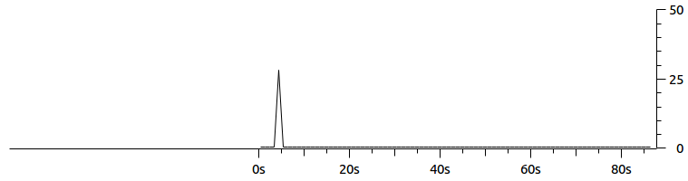

TCP Throughput (packets) for pic2.jpg

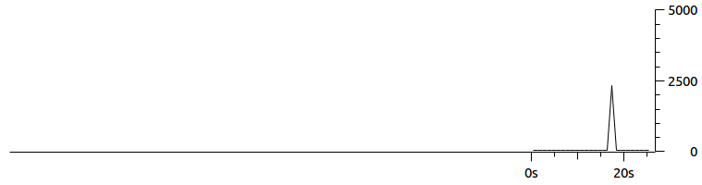
TCP Throughput (packets) for pic3.jpg

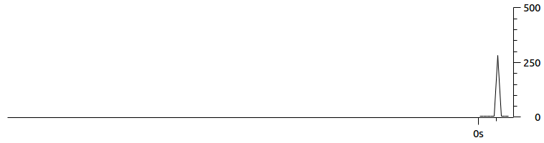
TCP Throughput (packets) for pic4.jpg

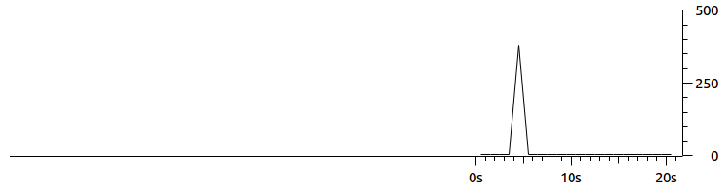

TCP Throughput (packets) for pic5.jpg

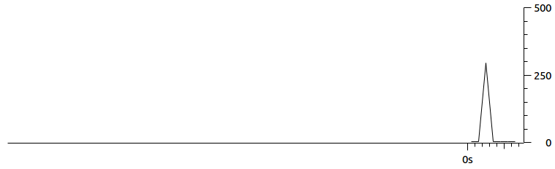

UDP Throughput (packets) for bandwidth 28Kbps

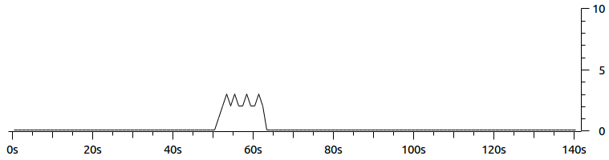
From these graphs, we can conclude that the UDP’s throughput is approximately constant for a long period of time whereas for TCP the throughput sharply increases and then sharply decreases.

(d)

UDP throughput from server report using iperf command for the bandwidth:

(i) 64 Kbps = 64.0 Kbits/sec 57 packets transmitted
(ii) 128 Kbps = 128 Kbits/sec 111 packets transmitted
(iii) 256 Kbps = 256 Kbits/sec 220 packets transmitted
(iv) 512 Kbps = 512 Kbits/sec 438 packets transmitted
(v) 1024 Kbps = 1.02 Mbits/sec 873 packets transmitted
(vi) 2048 Kbps = 2.05 Mbits/sec 1744 packets transmitted

(3)

The number of TCP packets retransmitted for the captured pic

Pic1 = 0
Pic2 = 0
Pic3 = 0
Pic4 = 0
Pic5 = 0

(4)

1.

2.

From these graphs, we can deduce that the throughput and the number of packets transmitted are an increasing function with respect to the bandwidth for UDP protocols. Also, this function is linear for speeds upto 2048 Kbps.

